|  |  |  |
| --- | --- | --- |
| Amogh Deshpande | Experiment # 6 |  |
| K012 |  | Date of Submission:- 9/ 02 /2022 |
| Class:-B.Tech IT/MBA.Tech IT/B.Tech (CS) | | Division:- A1 |

Aim:

1. Java script functions
2. Regular expression
3. Event handling
4. Validations and Query

Prerequisites:-

- OOPS concept and HTMLS basic tags Theory:-

//defining a function function <function-name>()

{

// code to be executed

};

//calling a function

<function-name>();

Function Declaration

* Function Function_Name(value1,value2)
* {
* return value1;
* Return value 2;
* }
  1. Example 1

<html>

<script type=“javascript”> Function add(a,b)

{

Return a+b;

}

Alert(add(1,2));

</script>

</body>

</html>

* 1. Example: Define and Call a Function function ShowMessage() { alert("Hello World!");

}

ShowMessage();

* 1. Example: Function Parameters function ShowMessage(firstName, lastName) {

alert("Hello " + firstName + " " + lastName);

}

ShowMessage("Steve", "Jobs"); ShowMessage("Bill", "Gates"); ShowMessage(100, 200);

* 1. Example :Iterate all Arguments function ShowMessage() {

for(var i = 0; i < arguments.length; i++){ alert(arguments[i]);

}

}

ShowMessage("Steve", "Jobs");

* [Dynamic HTML](http://en.wikipedia.org/wiki/Dynamic_HTML) (DHTML), functionality

In 1997, Netscape and Microsoft released version 4.0 of Netscape Navigator and Internet Explorer respectively, adding support for [Dynamic HTML](http://en.wikipedia.org/wiki/Dynamic_HTML) (DHTML), functionality enabling changes to a loaded HTML document.

getElementById()

The getElementById() method accesses the first element with the specified id

* **Syntax:-** document.getElementById("*id*")
* **Id:-** The id of the element you want to access/manipulate.
  1. Example 5

<html>

<head>

<script>

function getValue()

{

var x=document.getElementById("myHeader");

}

</script>

</head>

<body>

<h1 id="myHeader“ >Click me!</h1>

</body>

</html>

Try and catch

try

{

// code that may throw an error

}

catch(ex)

{

// code to be executed if an error occurs

}

finally{

// code to be executed regardless of an error occurs or not

}

*Error Handling in JS*

try

{

var result = Sum(10, 20); // Sum is not defined yet

}

catch(ex)

{

document.getElementById("errorMessage").innerHTML = ex;

}

Regular Expressions

* + A regular expression is an object that describes a pattern of characters.
  + The JavaScript **RegExp** class represents regular expressions.
  + **RegExp** define methods that use regular expressions to perform
  + powerful pattern-matching
  + search-and-replace functions on text.

var pattern = new RegExp(pattern, attributes);

**pattern:** A string that specifies the pattern of the regular expression.

**attributes:** An optional string containing any of the attributes that specify

* "g“ =global
* "i“ =case-insensitive
* "m" = multiline matches.
* Brackets ([]) have a special meaning.
* They are used to find a range of characters.

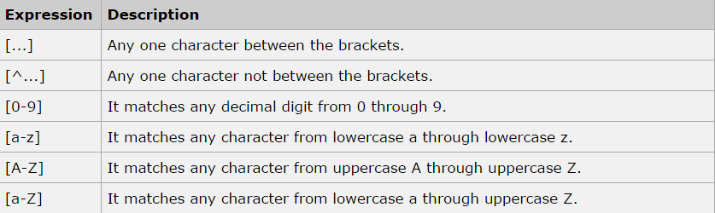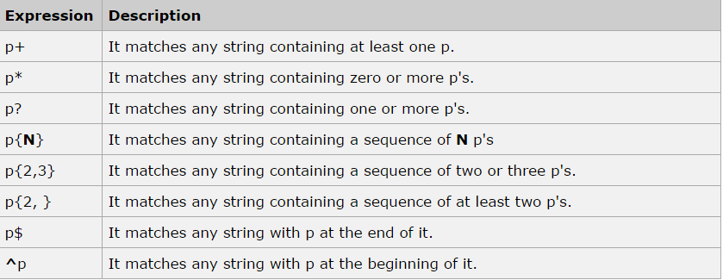

*Example 6*

<script type="javascript"> function hello(name)

{

alert("Hello" +name.value+ ".Nice to meet you"); return true;

}

</script>

<form>

Enter your name: <input type="text" name="fname" id="1">

<input type="button" onclick ="hello(document.getElementById('1'))" value="Submit">

</form> innerHTML

* The innerHTML property sets or returns the HTML content (inner HTML) of an element.
* Syntax
* Return the innerHTML property:
* *HTMLElementObject*.innerHTML
* Set the innerHTML property:
* *HTMLElementObject*.innerHTML=*text*

*Example* 8

<html>

<body>

<h1>My Web Page</h1>

<p id="myP">This is a p element.</p>

<div id="myDIV">This is a div element.</div>

<script>

document.getElementById("myP").innerHTML = "Hello Dolly."; document.getElementById("myDIV").innerHTML = "How are you?";

</script>

</body>

</html>

Use String replace() With a Regular Expression

* var str = "Visit Microsoft!";

var res = str.replace(/microsoft/i, "MPSTME");

* 1. Example 9

<html>

<body>

<h2>JavaScript Functions</h2>

<p>This example calls a function to convert from Fahrenheit to Celsius:</p>

<p id="demo"></p>

<script>

function toCelsius(f) { return (5/9) * (f-32);

}

**document.getElementById("demo").innerHTML = toCelsius(77);**

</script>

</body>

</html>

* 1. Example 10

<html>

<body>

<p>Click the button to display the date.</p>

<button onclick="displayDate()">The time is?</button>

<script>

function displayDate() { document.getElementById("demo").innerHTML = Date();

}

</script>

<p id="demo"></p>

</body>

</html>

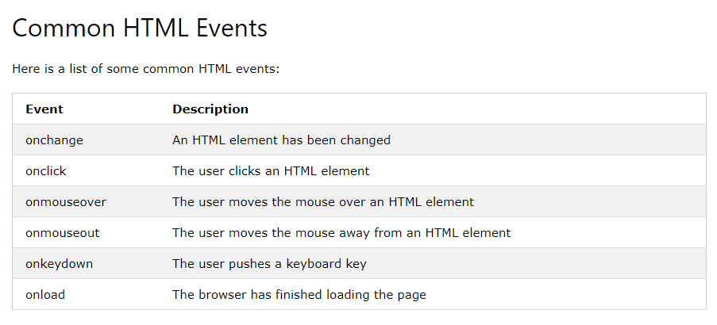

* 1. Example 11

<html>

<body>

<h2>JavaScript Arrays</h2>

<p>JavaScript array elements are accessed using numeric indexes (starting from 0).</p>

<p id="demo"></p>

<script>

var cars = ["Saab", "Volvo", "BMW"]; document.getElementById("demo").innerHTML = cars[0];

</script>

</body>

</html>

Change the Array Value

* var cars = ["Saab", "Volvo", "BMW"]; cars[0] = "Opel";

document.getElementById("demo").innerHTML = cars[0];

Length() function

var fruits = ["Banana", "Orange", "Apple", "Mango"]; document.getElementById("demo").innerHTML = fruits.length;

Access the first and last element of an Array

* fruits = ["Banana", "Orange", "Apple", "Mango"]; var first = fruits[0];
* fruits = ["Banana", "Orange", "Apple", "Mango"]; var last = fruits[fruits.length - 1];

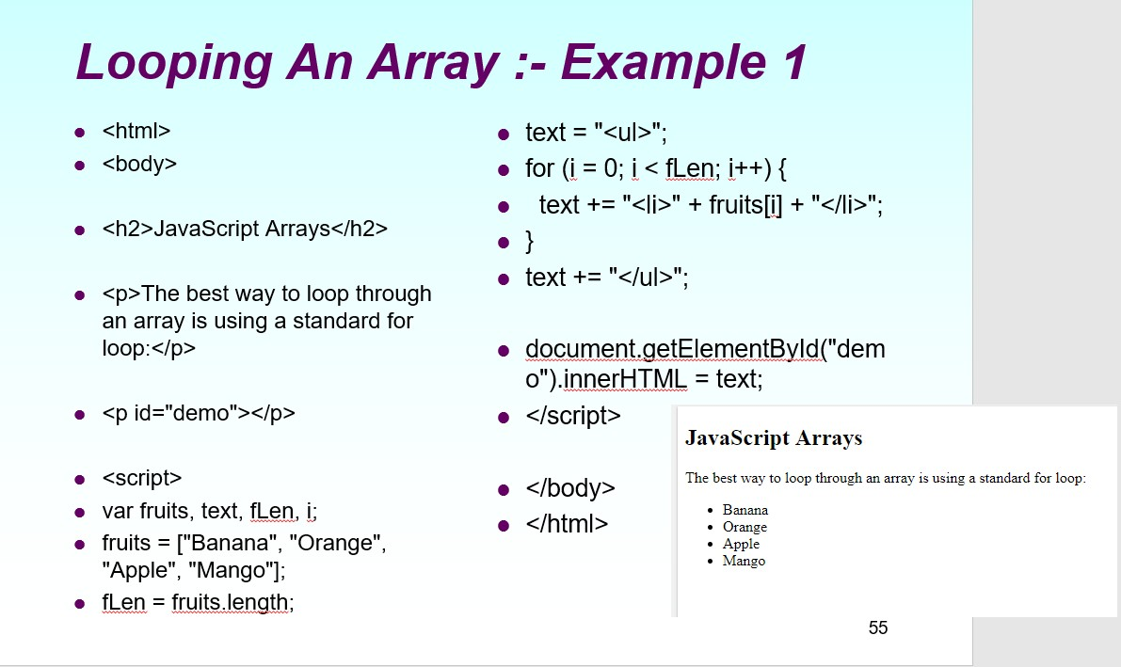

9. Example 12

1. Example 13

|  |  |  |  |  |  |
| --- | --- | --- | --- | --- | --- |
|  | | **SVKM’s NMIMS**  **Mukesh Patel School of Technology Management & Engineering Mumbai and Shirpur Campus** | | | |
| **IT Department** | | | |
| **Manual Prepared by**  **Prof.Sulalah Mirkar** | | | **Lab Manual** | **Academic Year- 2021-22** | |
| **Year:-** | | | **Subject:- Web Programming** | **Semester:-** | |
|  |  | | | |  |

ARRAY METHODS

* var fruits = ["Banana", "Orange", "Apple", "Mango"]; document.getElementById("demo").innerHTML = fruits.toString();
* var fruits = ["Banana", "Orange", "Apple", "Mango"]; document.getElementById("demo").innerHTML = fruits.join(" * ");
* OUTPUT :---Banana * Orange * Apple * Mango
* var fruits = ["Banana", "Orange", "Apple", "Mango"];

fruits.pop(); // Removes the last element ("Mango") from fruits

* var fruits = ["Banana", "Orange", "Apple", "Mango"]; fruits.push("Kiwi"); // Adds a new element ("Kiwi") to fruits
* var fruits = ["Banana", "Orange", "Apple", "Mango"];

fruits.shift(); // Removes the first element "Banana" from fruits

* var fruits = ["Banana", "Orange", "Apple", "Mango"];

fruits[0] = "Kiwi"; // Changes the first element of fruits to "Kiwi"

1. Example 14

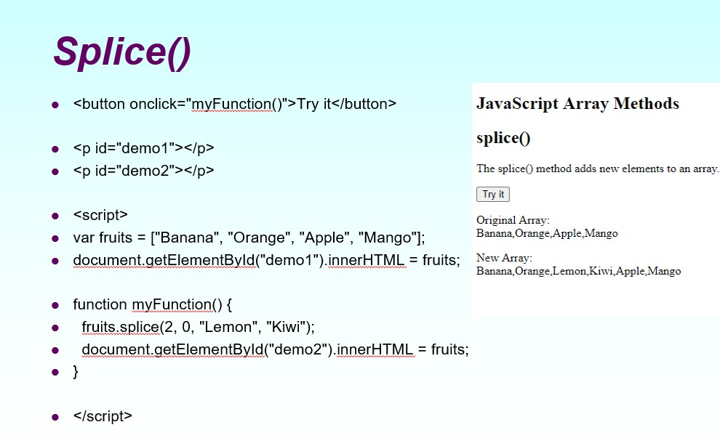

Concatenates

var myGirls = ["Cecilie", "Lone"];

var myBoys = ["Emil", "Tobias", "Linus"];

var myChildren = myGirls.concat(myBoys); // Concatenates (joins) myGirls and myBoys document.getElementById("demo").innerHTML = myChildren

Slice

var fruits = ["Banana", "Orange", "Lemon", "Apple", "Mango"]; var citrus = fruits.slice(1);

document.getElementById("demo").innerHTML = fruits + "<br><br>" + citrus;

/****output*****/

* + Banana,Orange,Lemon,Apple,Mango

Orange,Lemon,Apple,Mango

1. Example 15

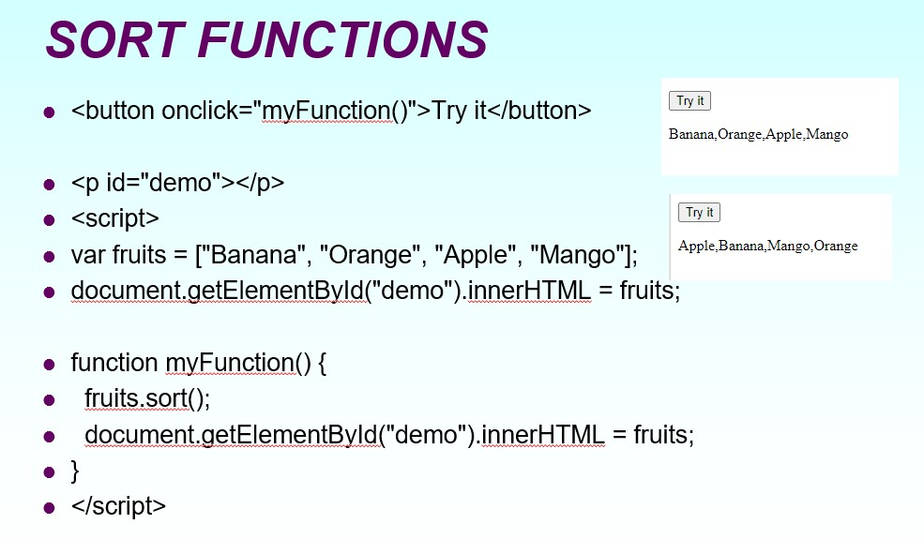

JavaScript Form Validation

* Form data that typically are checked by a JavaScript could be:
* has the user left required fields empty?
* has the user entered a valid e-mail address?
* has the user entered a valid date?
* has the user entered text in a numeric field?

|  |  |  |  |  |  |
| --- | --- | --- | --- | --- | --- |
|  | | **SVKM’s NMIMS**  **Mukesh Patel School of Technology Management & Engineering Mumbai and Shirpur Campus** | | | |
| **IT Department** | | | |
| **Manual Prepared by**  **Prof.Sulalah Mirkar** | | | **Lab Manual** | **Academic Year- 2021-22** | |
| **Year:-** | | | **Subject:- Web Programming** | **Semester:-** | |
|  |  | | | |  |

1. Example 16

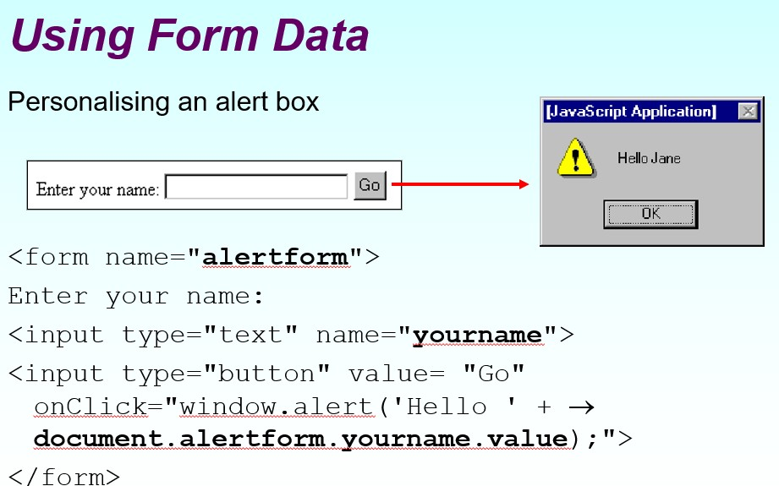

1. Example 17

|  |  |  |  |  |
| --- | --- | --- | --- | --- |
|  | **SVKM’s NMIMS**  **Mukesh Patel School of Technology Management & Engineering Mumbai and Shirpur Campus** | | | |
| **IT Department** | | | |
| **Manual Prepared by**  **Prof.Sulalah Mirkar** | | **Lab Manual** | **Academic Year- 2021-22** | |
| **Year:-** | | **Subject:- Web Programming** | **Semester:-** | |
|  | | | |  |

1. Example 18

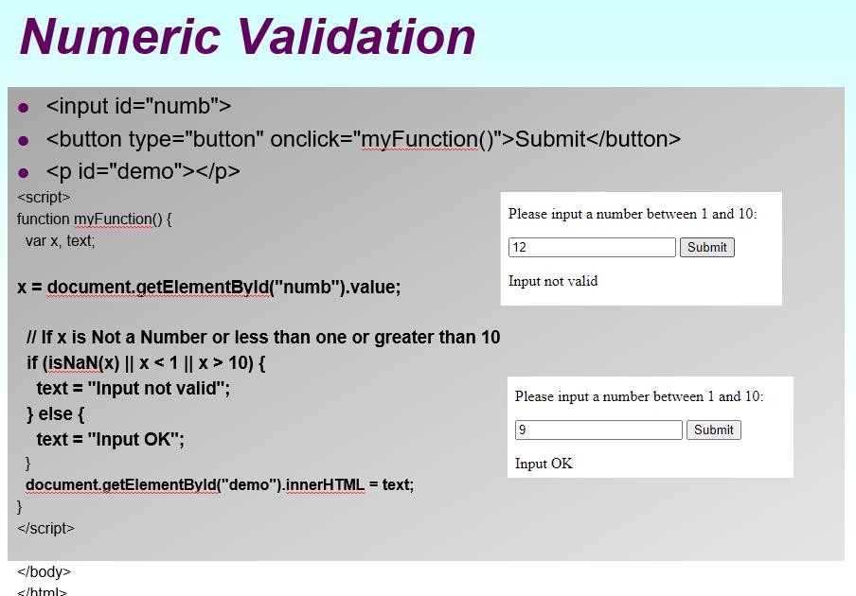

HTML form validation

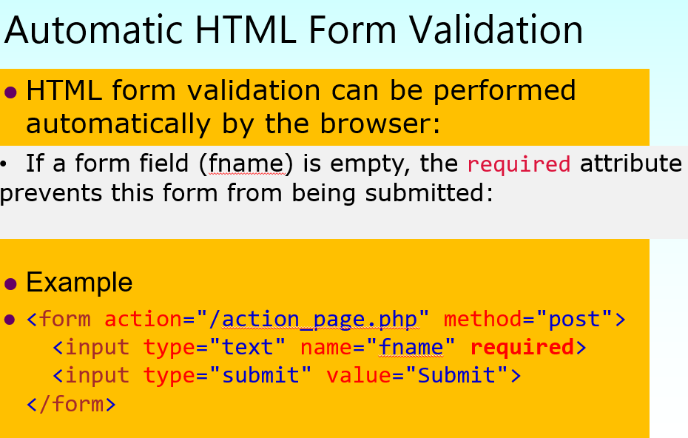

Data Validation

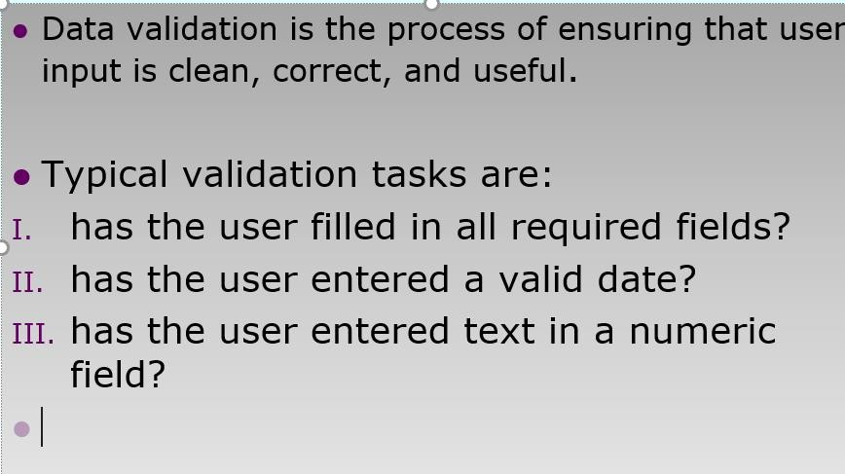

HTML Validations

* HTML constraint validation is based on:

1. Constraint validation **HTML Input Attributes**
2. Constraint validation **CSS Pseudo Selectors**
3. Constraint validation **DOM Properties and Methods**

Constraint validation **HTML Input Attributes**

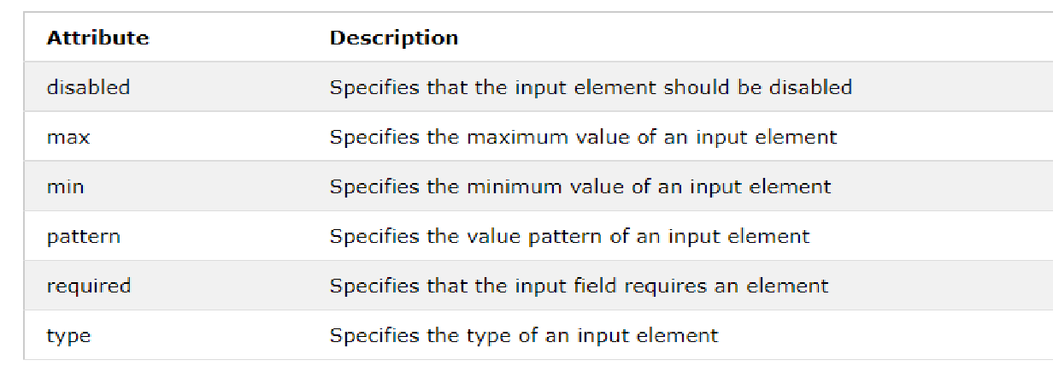

1. Example 19

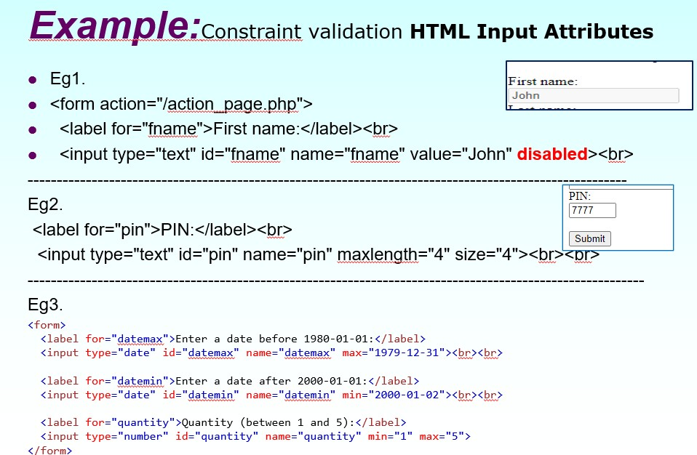

Output

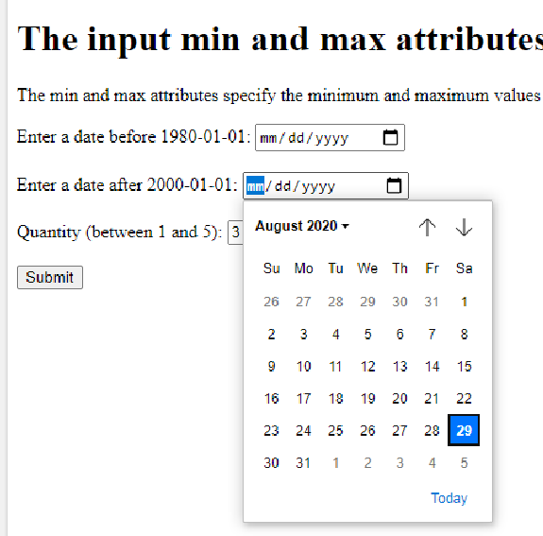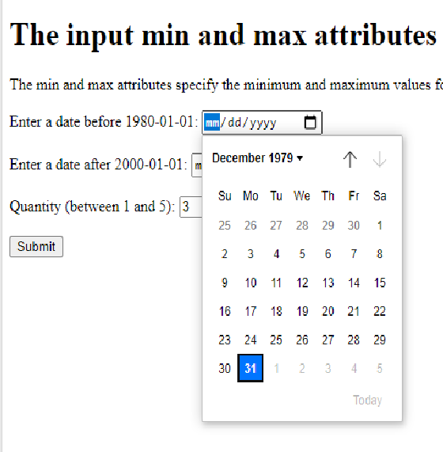

1. Example 20

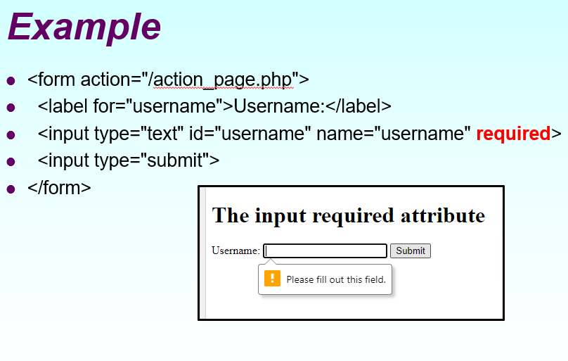

* 1. Constraint validation **CSS Pseudo Selectors**

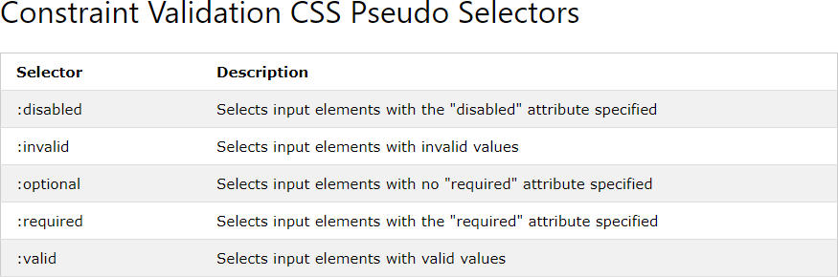

* 1. Constraint Validation DOM Methods

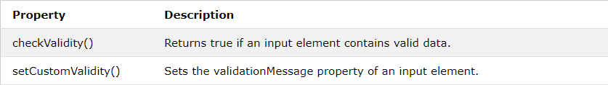

Constraint Validation DOM Properties

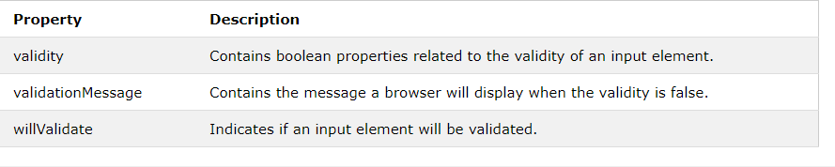

1. Example 21

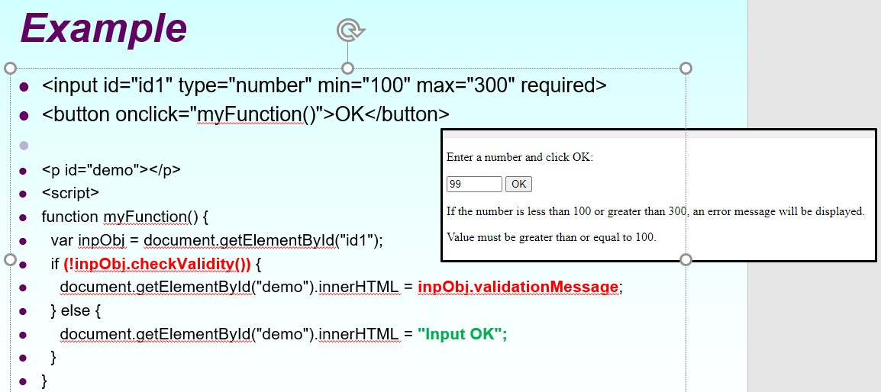

*Validity Properties*

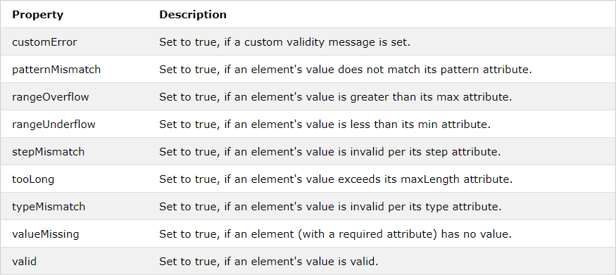

1. Example 22

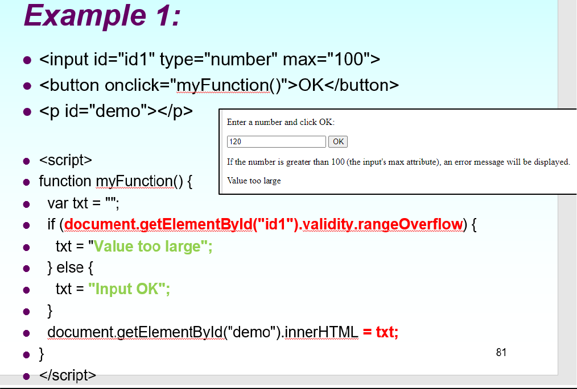

1. Example 23

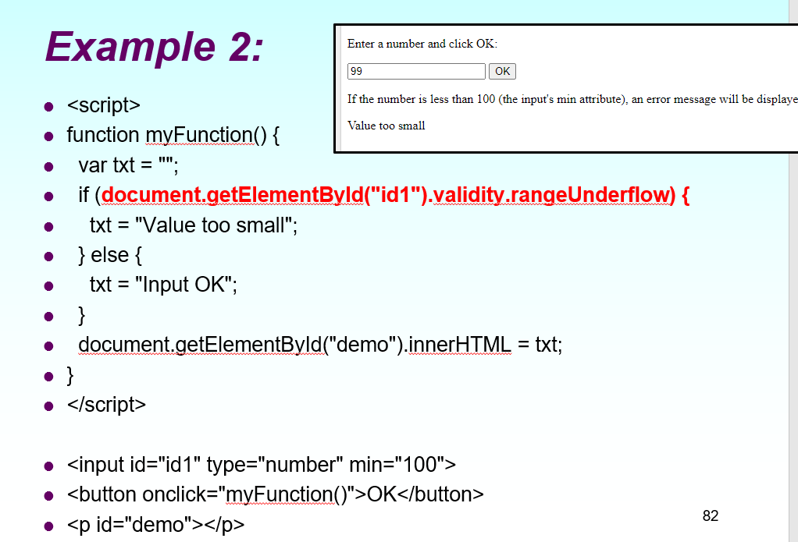

PART B

PRACTICE PROGRAMS:

1.

Code:

<!DOCTYPE html> <html>

<head><title>K012 Amogh Deshpande</title></head>

<body>

<h2>JavaScript String Methods</h2>

<p>Replace "Microsoft" with "W3Schools" in the paragraph below:</p>

<button onclick="myFunction()">Try it</button>

<p id="demo">Please visit Microsoft!</p>

<script> function myFunction() {

let text = document.getElementById("demo").innerHTML;

document.getElementById("demo").innerHTML = text.replace("Microsoft","W3Schools");

} </script>

</body>

</html>

Output:





2.

Code:

<!DOCTYPE html>

<html>

<head><title>K012 Amogh Deshpande</title></head>

<body>

<h2>JavaScript Arrays</h2>

<p id="demo"></p>

<script> const cars = [];

cars[0]= "Saab";

cars[1]= "Volvo";

cars[2]= "BMW";

document.getElementById("demo").innerHTML = cars;

</script>

</body>

</html>

Output:



3.

Code:

<!DOCTYPE html>

<html>

<head><title>K012 Amogh Deshpande</title></head>

<body>

<h2>JavaScript Array Methods</h2>

<h2>toString()</h2>

<p>The toString() method returns an array as a comma separated string:</p>

<p id="demo"></p>

<script>

const fruits = ["Banana", "Orange", "Apple", "Mango"];

document.getElementById("demo").innerHTML = fruits.toString();

</script>

</body>

</html>

Output:



4.

Code:

<!DOCTYPE html>

<html>

<body>

<h2>JavaScript Array Sort</h2>

<p>The sort() method sorts an array alphabetically:</p>

<p id="demo1"></p> <p id="demo2"></p>

<script>

const fruits = ["Banana", "Orange", "Apple", "Mango"];

document.getElementById("demo1").innerHTML = fruits;

fruits.sort();

document.getElementById("demo2").innerHTML = fruits;

</script>

</body>

</html>

Output:

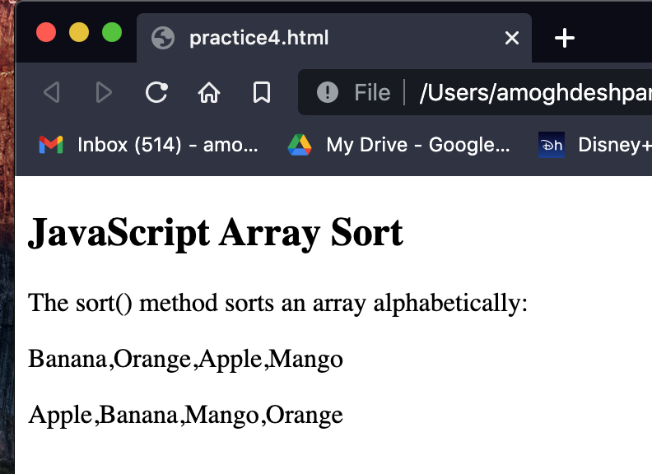

Functions , Events and Arrays

1. Write a Program to display Exponent of a two numbers using a JavaScript functions.
2. Write a Program to display a Moon weight and input will be actual earth weight .
3. Write a java script program to create an Array for the students whose length is 5 . and display with ordered list.
4. push the new students into an array and display the new array list on MouseOver Event on paragraph tags.
5. Splice ,new 3 students into an array on image Onclick Event.
6. concate the two array called girls and boys students on division Onclick Event.
7. slice the students array into 3 halves using slice function of java Script.
8. Validations 1
   1. Write a Program to Accept User Name , User Age ,User Phone Number.
   2. Check No user input is left or blank.
   3. User Name length should be 10 char long.
   4. User Age should be more than 20 and less than 90.
   5. User Phone length should be 10 digit long.
   6. Note:- User inner html for displaying an error message. 9.Form Validations 2

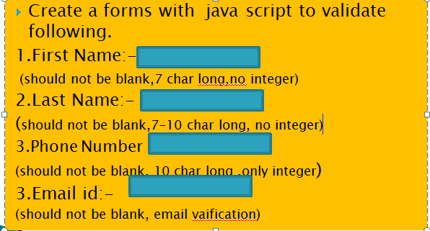

Program 1:

Code:-

<!DOCTYPE html>

<html lang="en-us">

<head><title>K012 Amogh Deshpande</title></head>

<body>

<p id="base"></p>

<p id="power"></p>

<p id ="answer"></p>

<script>

let a = 12;

let b = 4;

document.getElementById("base").innerHTML=a;

document.getElementById("power").innerHTML=b;

document.getElementById("answer").innerHTML=(a**b);

</script>

</body>

</html>

Output:

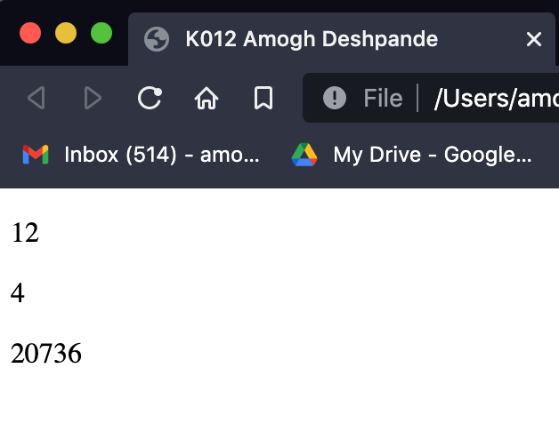

Program 2:

Code:

<!DOCTYPE html>

<html lang="en-us">

<head>

<title>K012 Amogh Deshpande</title>

</head>

<body>

<p>Your weight on moon is: </p>

<p id="weight"></p>

<script>

const weight = prompt("Enter your weight on earth:");

intweight = parseFloat(weight);

let moonWeight = intweight*(16.5/100);

document.getElementById("weight").innerHTML=moonWeight;

</script>

</body>

</html>

Output:





Program 3

Code:

<!DOCTYPE html>

<html lang="en-us">

<head><title>K012 Amogh Deshpande</title></head>

<body>

<p>The list of students is:</p>

<p id="students"></p>

<script>

const n = 5;

let a = [];

for(let i=0; i< n;i++){

a[i] = prompt("Enter name of student: ");

}

document.getElementById("students").innerHTML=a;

</script>

</body>

</html>

Output:









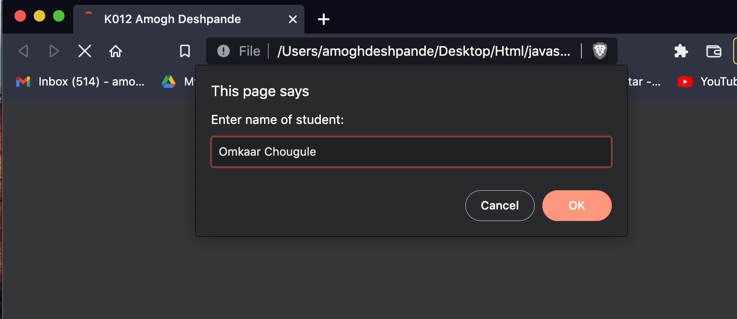



Program 4:

Code:

<!DOCTYPE html>

<html lang="en-us">

<head><title>K012 Amogh Deshpande</title></head>

<body>

<p>To get names of the students hover mouse over the below text:</p>

<p id="names" onmouseover="students()" onmouseout="names()">names</p>

<script>

function students(){

let a =["Amogh","Dinesh","Sagar","Gaurav","Omkaar"]

document.getElementById("names").innerHTML=a;

}

function names(){

document.getElementById("names").innerHTML="names";

}

</script>

</body>

</html>





Program 5:

Code:

<!DOCTYPE html>

<html lang="en-us">

<head><title>K012 Amogh Deshpande</title></head>

<body>

<p id="names"></p>

<span style="cursor: pointer"><img src="/Users/amoghdeshpande/Desktop/Html/Project2.0/1.jpeg" id="add" onclick="add()"></span>

<script>

let a = ["Amogh","Dinesh","Sagar"];

document.getElementById("names").innerHTML=a;

function add(){

let a = ["Amogh","Dinesh","Sagar"];

a.splice(3,0,"Gaurav","Omkaar","Sahil");

document.getElementById("add").innerHTML=a;

document.write(a);

}

</script>

</body>

</html>

Output:





Program 6:

Code:

<!DOCTYPE html>

<html lang="en-us">

<head>

<title> K012 Amogh Deshpande</title>

</head>

<body>

<p id="boys"></p>

<p id="girls"></p>

<p id="concat" onclick="concat(boys,girls)">Click on the text to concat the array</p>

<script>

let boys = ["BOY 1","BOY 2","BOY 3"];

let girls = ["GIRL 1","GIRL 2","GIRL 3"];

document.getElementById("boys").innerHTML= boys;

document.getElementById("girls").innerHTML= girls;

function concat(a,b){

c = a+b;

document.getElementById("concat").innerHTML=c;

}

</script>

</body>

</html>

Output:





Program 7:

Code:

<!DOCTYPE html>

<html lang="en-us">

<head><title>K012 Amogh Deshpande</title></head>

<body>

<p id="students"></p>

<p>Students array sliced into three equal parts:<br></p>

<p id= "s1"></p>

<p id= "s2"></p>

<p id= "s3"></p>

<script>

let students = ["BOY 1","BOY 2","BOY 3","GIRL 1","GIRL 2","GIRL 3"]

document.getElementById("students").innerHTML=students;

let s1 = students.slice(0,2);

let s2 = students.slice(2,4);

let s3 = students.slice(4,6);

document.getElementById("s1").innerHTML=s1;

document.getElementById("s2").innerHTML=s2;

document.getElementById("s3").innerHTML=s3;

</script>

</body>

</html>

Output:



Program 8:

<html>

<head>

<title>Form Validation</title>

<script type = "text/javascript">

function validate() {

if( document.myForm.Username.value == "" ) {

document.myForm.Username.focus() ;

let a="Please provide your Username!";

document.getElementById("alert").innerHTML=a;

return false;

}

if( document.myForm.age.value == "" ) {

let a="Please provide your Age!";

document.getElementById("alert").innerHTML=a;

document.myForm.age.focus() ;

return false;

}

if( document.myForm.phone.value == "") {

let a="Please provide your phone number!";

document.getElementById("alert").innerHTML=a;

document.myForm.phone.focus() ;

return false;

}

if( document.myForm.Username.value.length != 10 ) {

let a="Your username should be 10 character long";

document.getElementById("alert").innerHTML=a;

document.myForm.Username.focus();

return false;

}

if( document.myForm.phone.value.length != 10 ) {

let a="Your number should be 10 digits long";

document.getElementById("alert").innerHTML=a;

document.myForm.phone.focus();

return false;

}

if(document.myForm.age.value > 90 || document.myForm.age.value < 20){

let a="Age should be between 20 and 90!";

document.getElementById("alert").innerHTML=a;

document.myForm.age.focus();

return false;

}

return( true );

}

</script>

</head>

<body>

<form action="/action_page.php" name="myForm" onsubmit="return(validate());">

<label for="Username">Username:</label>

<input placeholder="abc" type="text" id="Username" name="Username">

<br>

<br>

<label for="age">Age:</label>

<input type="number" id="age" name="age">

<br>

<br>

<label for="phone">Phone:</label>

<input type="number" id="phone" name="phone" maxlength="10">

<br>

<br>

<input type="Submit">

</form>

<p id="alert" style="color: red;"></p>

</body>

</html>

Output:



Program 9:

Code:

<html>

<head><title></title></head>

<script>

function validate() {

if( document.myForm.fname.value == "" ) {

document.myForm.fname.focus() ;

let a="Please provide your First name!";

document.getElementById("alert").innerHTML=a;

return false;

}

if( document.myForm.lname.value == "" ) {

let a="Please provide your Last Name!";

document.getElementById("alert").innerHTML=a;

document.myForm.lname.focus() ;

return false;

}

if( document.myForm.phone.value == "") {

let a="Please provide your phone number!";

document.getElementById("alert").innerHTML=a;

document.myForm.phone.focus() ;

return false;

}

if(document.myForm.email.value==""){

let a="Please provide your email!";

document.getElementById("alert").innerHTML=a;

document.myForm.email.focus() ;

return false;

}

if( document.myForm.phone.value.length != 10 ) {

let a="Your number should be 10 digits long";

document.getElementById("alert").innerHTML=a;

document.myForm.phone.focus();

return false;

}

if(document.myForm.age.value > 90 || document.myForm.age.value < 20){

let a="Age should be between 20 and 90!";

document.getElementById("alert").innerHTML=a;

document.myForm.age.focus();

return false;

}

return( true );

}

</script>

<body>

<form name="myForm" action="/action_page.php" onsubmit="return(validate());">

<label for="fname">Firstname:</label>

<input type="text" id="fname" name="fname">

<br>

<br>

<label for="lname">Lastname:</label>

<input type="text" id="lname" name="lname">

<br>

<br>

<label for="phone">Phone No:</label>

<input type="number" id="phone" name="phone">

<br>

<br>

<label for="lname">Email ID:</label>

<input type="email" id="email" name="email">

<br>

<br>

<input type="Submit">

</form>

<p id="alert" style="color: red"></p>

</body>

</html>

Output:



Conclusion:-

We used javascript to peform calculations and validate forms in html.

Questions:-

1. What is meaning of inner html?

Ans: innerHTML is an Element property in JS that is used to get or set the HTML or XML markup contained within the element. innerHTML property can also be used to examine current HTML source of the page including any changes that have been made since the page was first loaded by the browser.

2. What is the meaning of DOM?

Ans: When a web page is loaded, the browser creates a Document Object Model of the page.

The HTML DOM model is constructed as a tree of Objects. With the object model, JavaScript gets all the power it needs to create dynamic HTML:

• JavaScript can change all the HTML elements in the page

• JavaScript can change all the HTML attributes in the page

• JavaScript can change all the CSS styles in the page

• JavaScript can remove existing HTML elements and attributes

• JavaScript can add new HTML elements and attributes

• JavaScript can react to all existing HTML events in the page

• JavaScript can create new HTML events in the page

3. Why Javascript is need to use on HTML web page?

Ans: Where HTML and CSS are languages that give structure and style to web pages, JavaScript gives web pages interactive elements that engage a user. Common examples of JavaScript that you might use every day include the search box on Amazon, a news recap video embedded on The New York Times, or refreshing your Twitter feed.

Incorporating JavaScript improves the user experience of the web page by converting it from a static page into an interactive one. To recap, JavaScript adds behavior to web pages.

avaScript is mainly used for web-based applications and web browsers. But JavaScript is also used beyond the Web in software, servers and embedded hardware controls. Here are some basic things JavaScript is used for:

1. Adding interactive behavior to web pages

JavaScript allows users to interact with web pages. There are almost no limits to the things you can do with JavaScript on a web page – these are just a few examples:

Show or hide more information with the click of a button Change the color of a button when the mouse hovers over it Slide through a carousel of images on the homepage Zooming in or zooming out on an image

Displaying a timer or count-down on a website Playing audio and video in a web page Displaying animations

2. Creating web and mobile apps

Developers can use various JavaScript frameworks for developing and building web and mobile apps. JavaScript frameworks are collections of JavaScript code libraries that provide developers with pre-written code to use for routine programming features and tasks— literally a framework to build websites or web applications around.

Popular JavaScript front-end frameworks include React, React Native, Angular, and Vue. Many companies use Node.js, a JavaScript runtime environment built on Google Chrome’s JavaScript V8 engine. A few famous examples include Paypal, LinkedIn, Netflix, and Uber!

3. Building web servers and developing server applications

Beyond websites and apps, developers can also use JavaScript to build simple web servers and develop the back-end infrastructure using Node.js.

4. Game development

Of course, you can also use JavaScript to create browser games. These are a great way for beginning developers to practice their JavaScript skills.